7.1.17 Editors - 3D View - Tool Shelf - Armature - Pose Mode
Tool Shelf - Armature - Pose Mode 2
Select, 3D Cursor, Transform, Annotate and Measure 2
Breakdowner Push Relax tools group 2
Breakdowner 2
Header Values 2
Last Operator Pose Breakdowner 2
Percentage 2
Previous Keyframe 2
Next Keyframe 2
Channels 3
Axis Lock 3
Push 3
Header Values 3
Last Operator Push Pose from Breakdown. 3
Previous Keyframe 3
Next Keyframe 3
Percentage 3
Channels 3
Axis Lock 3
Relax 3
Header Values 3
Last Operator Relax Pose to Breakdown 4
Previous Keyframe 4
Next Keyframe 4
Percentage 4
Channels 4
Axis Lock 4

Tool Shelf - Armature - Pose Mode
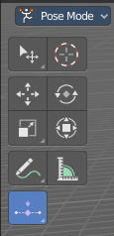
The Pose mode provides some pose tools.

Select, 3D Cursor, Transform, Annotate and Measure

The select and transform tools and the annotation and measure tool is already described in the chapter Object Mode. So we won't cover it here again.

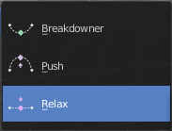
Breakdowner Push Relax tools group

Breakdowner
Creates a suitable breakdowner pose on the current frame. Requires to have a keyframe before and after the current position.

Header Values
When you move the mouse then you will see some values in the header, which shows the current factor. This value is relative to the starting value, which always starts with 0.
It also shows some more available transform hotkeys. The hotkeys W E and R allows you just to move, rotate or scale. Hotkey B stands for Bendy Bones. And C is for a custom property. This hotkeys are hard coded, and cannot be changed in the input manager.

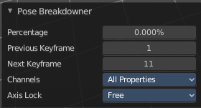
Last Operator Pose Breakdowner

Percentage
The percentage of exxageration. Interestingly the value in the Last operator differs from the value in the header.

Previous Keyframe
The keyframe position before the current frame.

Next Keyframe
The keyframe position after the current frame.

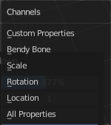
Channels
Which channels to affect.

Axis Lock
Lock the action to specific axis.

Push
Push exxagerrates the current pose.

Header Values
When you move the mouse then you will see some values in the header, which shows the current factor. This value is relative to the starting value, which always starts with 0.
It also shows some more available transform hotkeys. The hotkeys W E and R allows you just to move, rotate or scale. Hotkey B stands for Bendy Bones. And C is for a custom property. This hotkeys are hard coded, and cannot be changed in the input manager.

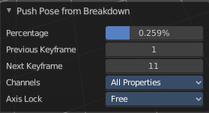
Last Operator Push Pose from Breakdown.

Previous Keyframe
The keyframe position before the current frame.

Next Keyframe
The keyframe position after the current frame.

Percentage
The percentage of exxageration. Interestingly the value in the Last operator differs from the value in the header.

Channels
Which channels to affect.

Axis Lock
Lock the action to specific axis.

Relax
Relax relaxes the current pose.

Header Values
When you move the mouse then you will see some values in the header, which shows the current factor. This value is relative to the starting value, which always starts with 0. It also shows some more available transform hotkeys.
It also shows some more available transform hotkeys. The hotkeys W E and R allows you just to move, rotate or scale. Hotkey B stands for Bendy Bones. And C is for a custom property. This hotkeys are hard coded, and cannot be changed in the input manager.

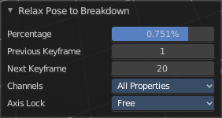
Last Operator Relax Pose to Breakdown

Previous Keyframe
The keyframe position before the current frame.

Next Keyframe
The keyframe position after the current frame.

Percentage
The percentage of exxageration. Interestingly the value in the Last operator differs from the value in the header.

Channels
Here you can again choose if you just want to limit a specific channel.

Axis Lock
Allows you to lock a specific axis.

